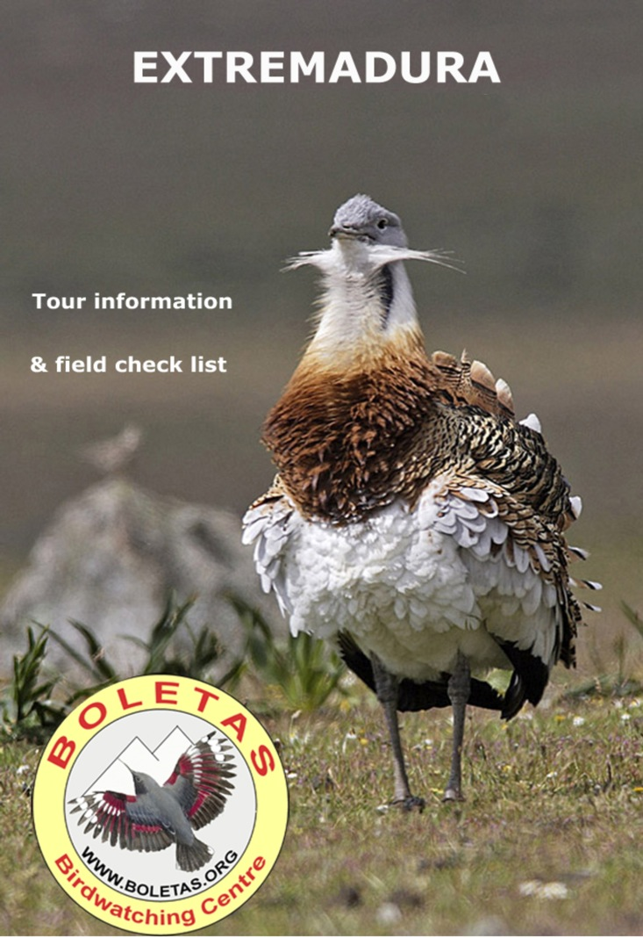
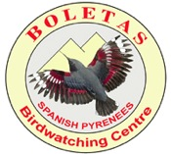
Birdwatching Holidays in Spain, Morocco & more…

BOLETAS Birdwatching centre
22192 Loporzano (Huesca) – Spain
tel/fax 00 34 974 262027 or 01162 889318
e.mail: josele@boletas.org
WWW.BIRDINGSPAIN.COM
Josele J. Saiz - NIF 38491538A

BIRDS of EXTREMADURA

FIELD CHECK LIST: Checklist order, common and scientific names used are those given in E. De Juana, List of the birds of the Iberian Peninsula, 1995, SEO_Birdlife. English ones are taken from the “British Birds” List of English names of Western Paleartic birds.

DAYLY REGISTER

Day 1- /Date________________ weather_____________________________________________________________________________

Itinerary_____________________________________________________________________________________

Day 2- /Date________________
weather _____________________________________________________________________________

Itinerary_____________________________________________________________________________________

Day 3- /Date________________
weather _____________________________________________________________________________

Itinerary_____________________________________________________________________________________

Day 4- /Date________________
weather _____________________________________________________________________________

Itinerary_____________________________________________________________________________________

Day 5- /Date________________
weather _____________________________________________________________________________

Itinerary_____________________________________________________________________________________

Day 6- /Date________________
weather _____________________________________________________________________________

Itinerary_____________________________________________________________________________________

Day 7- /Date________________
weather _____________________________________________________________________________

Itinerary_____________________________________________________________________________________

Day 8- /Date________________
weather _____________________________________________________________________________

Itinerary_____________________________________________________________________________________

RECOMMENDED SIGNS:
Seen ( X ) /Heard ( / ) Abundant (+++) Common (++) Rare (+) Juvenile (Juv) Immature (Inm) Adult (Ad) Female Male

 | English Name | Scientific name | 1 | 2 | 3 | 4 | 5 | 6 | 7 | 8
 | Great Crested Grebe | Podiceps cristatus
 | Black-necked Grebe | Podiceps nigricollis
 | Great Cormorant | Phalacrocorax carbo
 | Grey Heron | Ardea cinerea
 | Purple Heron | Ardea purpurea
 | Little Egret | Egretta garzetta
 | Great Egret | Egretta alba
 | Cattle Egret | Bubulcus ibis
 | Squacco Heron | Ardeola ralloides
 | Black-crowned Night-Heron | Nycticorax nycticorax
 | Great Bittern | Botaurus stellaris
 | Little Bittern | Ixobrychus minutus
 | Glossy Ibis | Plegadis falcinellus
 | Eurasian Spoonbill | Platalea leucorodia
 | White Stork | Ciconia ciconia
 | Black Stork | Ciconia nigra
 | Greater Flamingo | Phoenicopterus ruber
 | Common Shelduck | Tadorna tadorna
 | Mallard | Anas platyrhynchos
 | Gadwall | Anas strepera
 | Eurasian Wigeon | Anas penelope
 | Garganey | Anas querquedula
 | Common or Green-winged Teal | Anas crecca
 | Northern Pintail | Anas acuta
 | Northern Shoveler | Anas clypeata
 | Marbled Teal | Marmaronetta angustirostris
 | Red-crested Pochard | Netta rufina
 | Tufted Duck | Aythya fuligula
 | Ferruginous Duck | Aythya nyroca
 | Common Pochard | Aythya ferina
 | Common Merganser or Goosander | Mergus merganser
 | Egyptian Vulture | Neophron percnopterus
 | Lammergeier | Gypaetus barbatus
 | Cinereous, Black or Monk Vulture | Aegypius monachus
 | Eurasian Griffon Vulture | Gyps fulvus
 | Osprey | Pandion haliaetus
 | European Honey-Buzzard | Pernis apivorus
 | Red Kite | Milvus milvus
 | Black Kite | Milvus migrans migrans;
 | Black-winged or shouldered Kite | Elanus caeruleus
 | Bonelli's Eagle | Aquila fasciatus
 | Booted Eagle | Aquila pennatus
 | Golden Eagle | Aquila chrysaetos
 | Spanish Imperial Eagle | Aquila adalberti
 | Short-toed Snake-Eagle | Circaetus gallicus
 | Northern Goshawk | Accipiter gentilis
 | Eurasian Sparrowhawk | Accipiter nisus
 | Common Buzzard | Buteo buteo
 | Long-legged Buzzard | Buteo rufinus
 | Western or Eurasian Marsh Harrier | Circus aeruginosus
 | Northern or Hen Harrier | Circus cyaneus
 | Pallid Harrier | Circus macrourus
 | Montagu's Harrier | Circus pygargus
 | Peregrine Falcon | Falco peregrinus
 | Eurasian Hobby | Falco subbuteo
 | Merlin | Falco columbarius
 | Common or Eurasian Kestrel | Falco tinnunculus
 | Lesser Kestrel | Falco naummani
 | Common Quail | Coturnix coturnix
 | Grey Partridge | Perdix perdix
 | Red-legged Partridge | Alectoris rufa
 | Common Pheasant | Phasianus colchicus
 | Common Crane | Grus grus
 | Common Coot | Fulica atra
 | Purple Swamphen | Porphyrula porphyrula
 | Common Moorhen | Gallinula chloropus
 | Water Rail | Rallus aquaticus
 | Great Bustard | Otis tarda
 | Little Bustard | Tetrax tetrax
 | Black-winged Stilt | Himantopus himantopus
 | Northern Lapwing | Vanellus vanellus
 | European Golden-Plover | Pluvialis apricaria
 | Grey or Black-bellied Plover | Pluvialis squatarola
 | Common Ringed Plover | Charadrius hiaticula
 | Little Ringed Plover | Charadrius dubius
 | Kentish or Snowy Plover | Charadrius alexandrinus
 | Semipalmated Plover | Charadrius semipalmatus
 | Greater Sandplover | Charadrius leschenaultii
 | Ruddy Turnstone | Arenaria interpres
 | Dunlin | Calidris alpina
 | Curlew Sandpiper | Calidris ferruginea
 | Little Stint | Calidris minuta
 | Temminck's Stint | Calidris temminckii
 | Red Knot | Calidris canutus
 | Great Knot | Calidris tenuirostris
 | Sanderling | Calidris alba
 | Purple Sandpiper | Calidris maritima
 | Common Redshank | Tringa totanus
 | Spotted Redshank | Tringa erythropus
 | Common Greenshank | Tringa nebularia
 | Common Sandpiper | Tringa hypoleucos
 | Wood Sandpiper | Tringa glareola
 | Green Sandpiper | Tringa ochropus
 | Ruff | Philomachus pugnax
 | Eurasian Curlew | Numenius arquata
 | Black-tailed Godwit | Limosa limosa
 | Common Snipe | Gallinago gallinago
 | Eurasian Thick-knee or Stone Curlew | Burhinus oedicnemus
 | Collared Pratincole | Glareola pratincola
 | Black-headed Gull | Larus ridibundus
 | Great Black-backed Gull | Larus marinus
 | European Herring Gull | Larus argentatus
 | Yellow-legged Gull | Larus michahellis
 | Lesser Black-backed Gull | Larus fuscus
 | Gull-billed Tern | Sterna nilotica
 | Sandwich Tern | Sterna sandvicensis
 | Common Tern | Sterna hirundo
 | Little Tern | Sterna albifrons
 | Caspian Tern | Sterna caspia
 | Pin-tailed Sandgrouse | Pterocles alchata
 | Black-bellied Sandgrouse | Pterocles orientalis
 | Pallas’s Sandgrouse | Syrrhaptes paradoxus
 | Rock Dove | Columba livia
 | Feral Pigeon | Columba livia feral
 | Stock Dove | Columba oenas
 | Common Wood-Pigeon | Columba palumbus
 | Eurasian Collared-Dove | Streptopelia decaocto
 | European Turtle-Dove | Streptopelia turtur
 | Great Spotted Cuckoo | Clamator glandarius
 | Common or Eurasian Cuckoo | Cuculus canorus
 | Barn Owl | Tyto alba
 | Eurasian Eagle-Owl | Bubo bubo
 | Long-eared Owl | Asio otus
 | Short-eared Owl | Asio flammeus
 | Common or Eurasian Scops-Owl | Otus scops
 | Little Owl | Athene noctua
 | Tawny Owl | Strix aluco
 | Eurasian Nightjar | Caprimulgus europaeus
 | Red-necked Nightjar | Caprimulgus ruficollis
 | Common Swift | Apus apus
 | Pallid Swift | Apus pallidus
 | White-rumped Swift | Apus caffer
 | Alpine Swift | Apus melba
 | Common Kingfisher | Alcedo atthis
 | European Bee-eater | Merops apiaster
 | European Roller | Coracias garrulus
 | Eurasian or Common Hoopoe | Upupa epops
 | Eurasian Wryneck | Jynx torquilla
 | Great Spotted Woodpecker | Dendrocopos major
 | Eurasian Green Woodpecker | Picus viridis
 | Calandra Lark | Melanocorypha calandra
 | Sky Lark or Skylark | Alauda arvensis
 | Dupont’s Lark | Chersophilus duponti
 | Wood Lark or Woodlark | Lullula arborea
 | Crested Lark | Galerida cristata
 | Thekla Lark | Galerida theklae
 | Greater Short-toed Lark | Calandrella brachydactyla
 | Lesser Short-toed Lark | Calandrella rufescens
 | Eurasian Crag-Martin | Hirundo rupestris
 | Barn Swallow | Hirundo rustica
 | Red-rumped Swallow | Hirundo daurica
 | Northern House-Martin | Delichon urbica
 | Sand Martin | Riparia riparia
 | Tawny Pipit | Anthus campestris
 | White Wagtail | Motacilla alba
 | Blue-headed or Yellow Wagtail | Motacilla flava flava; M.f.iberiae; M.f.beema
 | Grey Wagtail | Motacilla cinerea
 | Woodchat Shrike | Lanius senator senator; L.s.badius
 | Southern Grey Shrike | Lanius meridionalis
 | Lesser Grey Shrike | Lanius minor
 | Hedge Accentor or Dunnock | Prunella modularis
 | Savi's Warbler | Locustella luscinioides
 | Great Reed-Warbler | Acrocephalus arundinaceus
 | Eurasian Reed-Warbler | Acrocephalus scirpaceus
 | Zitting Cisticola | Cisticola juncidis
 | Cetti's Warbler | Cettia cetti
 | Melodious Warbler | Hippolais polyglotta
 | Olivaceous Warbler | Hippolais pallida
 | Orphean Warbler | Sylvia hortensis
 | Blackcap | Sylvia atricapilla
 | Sardinian Warbler | Sylvia melanocephala
 | Subalpine Warbler | Sylvia cantillans
 | Spectacled Warbler | Sylvia conspicillata
 | Dartford Warbler | Sylvia undata
 | Western Bonelli's Warbler | Phylloscopus bonelli
 | Common or Eurasian Chiffchaff | Phylloscopus collybita
 | Iberian Chiffchaff | Phylloscopus ibericus ibericus;
 | Firecrest | Regulus ignicapillus
 | European Pied-Flycatcher | Ficedula hypoleuca
 | Spotted Flycatcher | Muscicapa striata
 | Common Stonechat | Saxicola rubicola
 | Rufous-tailed Scrub-Robin | Cercotrichas galactotes
 | Rufous-tailed Rock-Thrush | Monticola saxatilis
 | Blue Rock-Thrush | Monticola solitarius
 | Northern Wheatear | Oenanthe oenanthe
 | Black-eared Wheatear | Oenanthe hispanica
 | Black Wheatear | Oenanthe leucura
 | Common Redstart | Phoenicurus phoenicurus
 | Black Redstart | Phoenicurus ochruros
 | European Robin | Erithacus rubecula
 | Bluethroat | Luscinia svecica
 | Common Nightingale | Luscinia megarhynchos
 | Mistle Thrush | Turdus viscivorus
 | Fieldfare | Turdus pilaris
 | Eurasian or Common Blackbird | Turdus merula
 | Ring Ouzel | Turdus torquatus
 | Bearded Tit or Reedling | Panurus biarmicus
 | Long-tailed Tit | Aegithalos caudatus
 | Eurasian Penduline-Tit | Remiz pendulinus
 | Crested Tit | Parus cristatus
 | European Blue Tit | Parus caeruleus
 | Coal Tit | Parus ater
 | Great Tit | Parus major
 | Eurasian or Wood Nuthatch | Sitta europaea caesia
 | Short-toed Treecreeper | Certhia brachydactyla
 | White-throated Dipper | Cinclus cinclus
 | Winter Wren | Troglodytes troglodytes
 | Eurasian Jay | Garrulus glandarius
 | Eurasian Magpie | Pica pica
 | Azure-winged Magpie | Cyanopica cyana
 | Common or Northern Raven | Corvus corax
 | Rook | Corvus frugilegus
 | Carrion Crow | Corvus corone
 | Eurasian Jackdaw | Corvus monedula
 | Red-billed Chough | Pyrrhocorax pyrrhocorax
 | Yellow-billed or Alpine Chough | Pyrrhocorax graculus
 | House Sparrow | Passer domesticus
 | Spanish or Willow Sparrow | Passer hispaniolensis
 | Eurasian Tree-Sparrow | Passer montanus
 | Spotless Starling | Sturnus unicolor
 | Eurasian Golden-Oriole | Oriolus oriolus
 | Common Waxbill (introduced) | Estrilda astrild
 | Chaffinch | Fringilla coelebs
 | Blue Chaffinch | Fringilla teydea
 | European Serin | Serinus serinus
 | European Goldfinch | Carduelis carduelis
 | European Greenfinch | Carduelis chloris
 | Eurasian Linnet | Carduelis cannabina
 | Hawfinch | Coccothraustes coccothraustes
 | Rock Sparrow or Petronia | Petronia petronia
 | White-winged Snowfinch | Montifringilla nivalis
 | Corn Bunting | Emberiza calandra
 | Cirl Bunting | Emberiza cirlus
 | Ortolan Bunting | Emberiza hortulana
 | Rock Bunting | Emberiza cia

