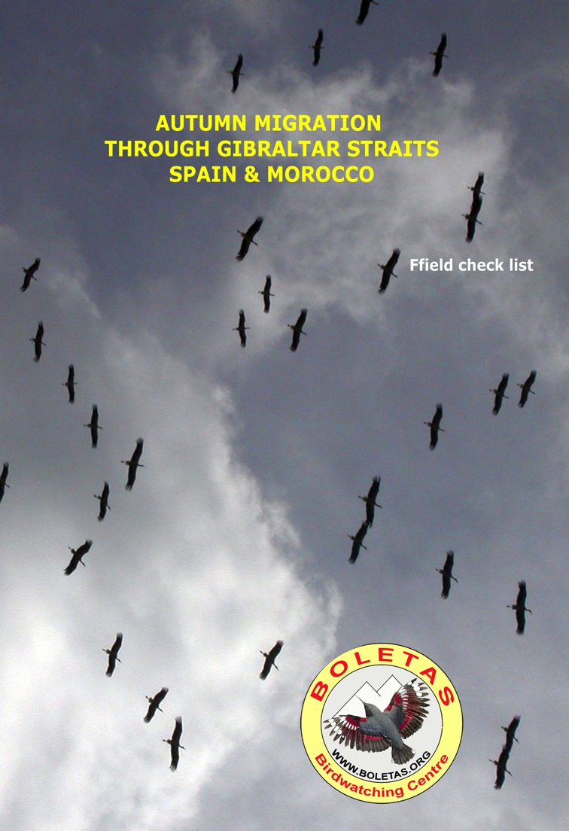
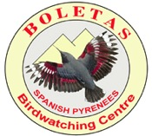
Birdwatching Holidays in Spain, Morocco & more…

BOLETAS Birdwatching centre

22192 Loporzano (Huesca) – Spain
tel/fax 00 34 974 262027 or 01162 889318
e.mail: josele@boletas.org

WWW.BIRDINGSPAIN.COM

Josele J. Saiz - NIF 38491538A

Birds of Spain & Morocco

DAYLY REGISTER

Day 1- / ________________ weather_______________________________________________________________________

Itinerary______________________________________________________________________________________________

Day 2 -/________________ weather_______________________________________________________________________

Itinerary______________________________________________________________________________________________

Day 3-/________________ weather_______________________________________________________________________
Itinerary______________________________________________________________________________________________

Day 4- / ________________ weather_______________________________________________________________________

Itinerary______________________________________________________________________________________________

Day 5- / ________________ weather_______________________________________________________________________

Itinerary______________________________________________________________________________________________

Day 6- / ________________ weather_______________________________________________________________________

Itinerary______________________________________________________________________________________________

Day 7- / ________________ weather_______________________________________________________________________

Itinerary______________________________________________________________________________________________

Day 8- / ________________ weather_______________________________________________________________________
Itinerary______________________________________________________________________________________________

RECOMMENDED SIGNS:
Vista/Seen ( X ) Oida/Heard (H )Abundant (XXX) Common (XX) Rare (+) Juvenile (Juv) Immature (Inm) Adult (ad) Female Male

# |  | Species | Scientific Name | 1 | 2 | 3 | 4 | 5 | 6 | 7 | 8
 |  | Little Grebe | Tachybaptus ruficollis
 |  | Great Crested Grebe | Podiceps cristatus
 |  | Cory's Shearwater | Calonectris diomedea
 |  | Manx Shearwater | Puffinus puffinus
 |  | Balearic Shearwater | Puffinus yelkouan mauretanicus
 |  | Northern Gannet | Morus bassanus
 |  | Great Cormorant | Phalacrocorax carbo maroccanus
 |  | European Shag | Phalacrocorax aristotelis
 |  | Grey Heron | Ardea cinerea
 |  | Purple Heron | Ardea purpurea
 |  | Little Egret | Egretta garzetta
 |  | Squacco Heron | Ardeola ralloides
 |  | Cattle Egret | Bubulcus ibis
 |  | Black-crowned Night Heron | Nycticorax nycticorax
 |  | Little Bittern | Ixobrychus minutus
 |  | Great Bittern | Botaurus stellaris
 |  | Black Stork | Ciconia nigra
 |  | White Stork | Ciconia ciconia
 |  | Bald Ibis | Geronticus eremita
 |  | Glossy Ibis | Plegadis falcinellus
 |  | Eurasian Spoonbill | Platalea leucorodia
 |  | Greater Flamingo | Phoenicopterus ruber
 |  | Ruddy Shelduck | Tadorna ferruginea
 |  | Common Shelduck | Tadorna tadorna
 |  | Eurasian Wigeon | Anas penelope
 |  | Gadwall | Anas strepera
 |  | Common Teal | Anas crecca
 |  | Mallard | Anas platyrhynchos
 |  | Northern Pintail | Anas acuta
 |  | Garganey | Anas querquedula
 |  | Northern Shoveler | Anas clypeata
 |  | Marbled Teal | Marmaronetta angustirostris
 |  | Red-crested Pochard | Netta rufina
 |  | Common Pochard | Aythya ferina
 |  | Ferruginous Pochard | Aythya nyroca
 |  | Tufted Duck | Aythya fuligula
 |  | Osprey | Pandion haliaetus
 |  | European Honey Buzzard | Pernis apivorus
 |  | Black-shouldered Kite | Elanus caeruleus
 |  | Red Kite | Milvus milvus
 |  | Black Kite | Milvus migrans
 |  | Lammergeier | Gypaetus barbatus
 |  | Egyptian Vulture | Neophron percnopterus
 |  | Griffon Vulture | Gyps fulvus
 |  | Short-toed Eagle | Circaetus gallicus
 |  | Western Marsh Harrier | Circus aeruginosus
 |  | Northern Harrier | Circus cyaneus
 |  | Montagu's Harrier | Circus pygargus
 |  | Dark Chanting Goshawk | Melierax metabates
 |  | Eurasian Sparrowhawk | Accipiter nisus punicus
 |  | Northern Goshawk | Accipiter gentilis
 |  | Common Buzzard | Buteo buteo
 |  | Spanish Imperial Eagle | Aquila adalberti
 |  | Golden Eagle | Aquila chrysaetos
# |  | Species | Scientific Name | 1 | 2 | 3 | 4 | 5 | 6 | 7 | 8
 |  | Bonelli's Eagle | Hieraaetus fasciatus
 |  | Booted Eagle | Hieraaetus pennatus
 |  | Lesser Kestrel | Falco naumanni
 |  | Eurasian Kestrel | Falco tinnunculus
 |  | Eleonora's Falcon | Falco eleonorae
 |  | Eurasian Hobby | Falco subbuteo
 |  | Barbary Falcon | Falco pelegrinoides
 |  | Peregrine Falcon | Falco peregrinus
 |  | Barbary Partridge | Alectoris barbara
 |  | Common Quail | Coturnix coturnix
 |  | Common Pheasant | Phasianus colchicus
 |  | Water Rail | Rallus aquaticus
 |  | Little Crake | Porzana parva
 |  | Baillon's Crake | Porzana pusilla
 |  | Spotted Crake | Porzana porzana
 |  | Purple Swamphen | Porphyrio porphyrio
 |  | Common Moorhen | Gallinula chloropus
 |  | Red-knobbed Coot | Fulica cristata
 |  | Eurasian Coot | Fulica atra
 |  | Eurasian Oystercatcher | Haematopus ostralegus
 |  | Black-winged Stilt | Himantopus himantopus
 |  | Pied Avocet | Recurvirostra avosetta
 |  | Eurasian Thick-knee | Burhinus oedicnemus
 |  | Collared Pratincole | Glareola pratincola
 |  | Northern Lapwing | Vanellus vanellus
 |  | Eurasian Golden Plover | Pluvialis apricaria
 |  | Black-bellied Plover | Pluvialis squatarola
 |  | Common Ringed Plover | Charadrius hiaticula
 |  | Little Ringed Plover | Charadrius dubius
 |  | Kentish Plover | Charadrius alexandrinus
 |  | Eurasian Dotterel | Charadrius morinellus
 |  | Common Snipe | Gallinago gallinago
 |  | Black-tailed Godwit | Limosa limosa
 |  | Bar-tailed Godwit | Limosa lapponica
 |  | Whimbrel | Numenius phaeopus
 |  | Eurasian Curlew | Numenius arquata
 |  | Spotted Redshank | Tringa erythropus
 |  | Common Redshank | Tringa totanus
 |  | Common Greenshank | Tringa nebularia
 |  | Green Sandpiper | Tringa ochropus
 |  | Wood Sandpiper | Tringa glareola
 |  | Common Sandpiper | Actitis hypoleucos
 |  | Ruddy Turnstone | Arenaria interpres
 |  | Red Knot | Calidris canutus
 |  | Sanderling | Calidris alba
 |  | Little Stint | Calidris minuta
 |  | Temminck's Stint | Calidris temminckii
 |  | Curlew Sandpiper | Calidris ferruginea
 |  | Dunlin | Calidris alpina
 |  | Ruff | Philomachus pugnax
 |  | Great Skua | Stercorarius skua
 |  | Pomarine Skua | Stercorarius pomarinus
 |  | Arctic Skua | Stercorarius parasiticus
 |  | Audouin's Gull | Larus audouinii
 |  | Western Yellow-legged Gull | Larus cachinnans michahellis
# |  | Species | Scientific Name | 1 | 2 | 3 | 4 | 5 | 6 | 7 | 8
 |  | Lesser Black-backed Gull | Larus fuscus graellsi
 |  | Black-headed Gull | Larus ridibundus
 |  | Slender-billed Gull | Larus genei
 |  | Mediterranean Gull | Larus melanocephalus
 |  | Gull-billed Tern | Sterna nilotica
 |  | Caspian Tern | Sterna caspia
 |  | Lesser Crested Tern | Sterna bengalensis
 |  | Sandwich Tern | Sterna sandvicensis
 |  | Common Tern | Sterna hirundo
 |  | Little Tern | Sterna albifrons
 |  | Whiskered Tern | Chlidonias hybridus
 |  | Black Tern | Chlidonias niger
 |  | Pin-tailed Sandgrouse | Pterocles alchata c
 |  | Black-bellied Sandgrouse | Pterocles orientalis
 |  | Rock Dove / Feral Pigeon | Columba livia
 |  | Stock Pigeon | Columba oenas
 |  | Common Woodpigeon | Columba palumbus
 |  | Eurasian Turtle Dove | Streptopelia turtur
 |  | Eurasian Collared Dove | Streptopelia decaocto
 |  | Laughing Dove | Streptopelia senegalensis
 |  | Great Spotted Cuckoo | Clamator glandarius
 |  | Common Cuckoo | Cuculus canorus
 |  | Barn Owl | Tyto alba
 |  | European Scops Owl | Otus scops
 |  | Pharaoh Eagle Owl | Bubo ascalaphus
 |  | Tawny Owl | Strix aluco mauritanica
 |  | Little Owl | Athene noctua
 |  | Northern Long-eared Owl | Asio otus
 |  | Short-eared Owl | Asio flammeus
 |  | Marsh Owl | Asio capensis tingitanus
 |  | Red-necked Nightjar | Caprimulgus ruficollis
 |  | Eurasian Nightjar | Caprimulgus europaeus
 |  | Egyptian Nightjar | Caprimulgus aegyptius
 |  | Alpine Swift | Tachymarptis melba
 |  | Common Swift | Apus apus
 |  | Pallid Swift | Apus pallidus
 |  | Little Swift | Apus affinis
 |  | White-rumped Swift | Apus caffer
 |  | Common Kingfisher | Alcedo atthis
 |  | European Bee-eater | Merops apiaster
 |  | European Roller | Coracias garrulus
 |  | Eurasian Hoopoe | Upupa epops
 |  | Eurasian Wryneck | Jynx torquilla
 |  | Great Spotted Woodpecker | Dendrocopos major
 |  | Calandra Lark | Melanocorypha calandra
 |  | Greater Short-toed Lark | Calandrella cinerea
 |  | Crested Lark | Galerida cristata
 |  | Thekla Lark | Galerida theklae
 |  | Wood Lark | Lullula arborea
 |  | Bank Swallow | Riparia riparia
 |  | Eurasian Crag Martin | Hirundo rupestris
 |  | Barn Swallow | Hirundo rustica
 |  | Red-rumped Swallow | Hirundo daurica
 |  | House Martin | Delichon urbica
 |  | White Wagtail | Motacilla alba
# |  | Species | Scientific Name | 1 | 2 | 3 | 4 | 5 | 6 | 7 | 8
 |  | Moroccan Wagtail | Motacilla alba subpersonata
 |  | Blue-headed Wagtail | Motacilla flava
 |  | Yellow Wagtail | Motacilla flava flavissima
 |  | Ashy-headed Wagtail | Motacilla flava cinereocapilla
 |  | Spanish Yellow Wagtail | Motacilla flava iberiae
 |  | Grey Wagtail | Motacilla cinerea
 |  | Tawny Pipit | Anthus campestris
 |  | Common Bulbul | Pycnonotus barbatus
 |  | Firecrest | Regulus ignicapillus
 |  | White-throated Dipper | Cinclus cinclus
 |  | Eurasian Wren | Troglodytes troglodytes
 |  | Rufous-tailed Rock Thrush | Monticola saxatilis
 |  | Blue Rock Thrush | Monticola solitarius
 |  | Eurasian Blackbird | Turdus merula
 |  | Song Thrush | Turdus philomelos
 |  | Mistle Thrush | Turdus viscivorus
 |  | Zitting Cisticola | Cisticola juncidis
 |  | Cetti's Warbler | Cettia cetti
 |  | Grasshopper Warbler | Locustella naevia
 |  | Savi's Warbler | Locustella luscinioides
 |  | Moustached Warbler | Acrocephalus melanopogon
 |  | Sedge Warbler | Acrocephalus schoenobaenus
 |  | Eurasian Reed Warbler | Acrocephalus scirpaceus
 |  | Great Reed Warbler | Acrocephalus arundinaceus
 |  | W. Olivaceous Warbler | Hippolais pallida
 |  | Melodious Warbler | Hippolais polyglotta
 |  | Willow Warbler | Phylloscopus trochilus
 |  | Common Chiffchaff | Phylloscopus collybita
 |  | Iberian Chiffchaff | Phylloscopus iberiae
 |  | Western Bonelli's Warbler | Phylloscopus bonelli
 |  | Wood Warbler | Phylloscopus sibilatrix
 |  | Blackcap | Sylvia atricapilla
 |  | Garden Warbler | Sylvia borin
 |  | Greater Whitethroat | Sylvia communis
 |  | Western Orphean Warbler | Sylvia hortensis
 |  | Subalpine Warbler | Sylvia cantillans
 |  | Sardinian Warbler | Sylvia melanocephala
 |  | Spectacled Warbler | Sylvia conspicillata
 |  | Dartford Warbler | Sylvia undata
 |  | European Pied Flycatcher | Ficedula hypoleuca
 |  | Common Nightingale | Luscinia megarhynchos
 |  | Rufous-tailed Scrub Robin | Cercotrichas galactotes
 |  | Black Redstart | Phoenicurus ochruros
 |  | Common Redstart | Phoenicurus phoenicurus
 |  | Moussier's Redstart | Phoenicurus moussieri
 |  | Whinchat | Saxicola rubetra
 |  | Common Stonechat | Saxicola torquata
 |  | Black Wheatear | Oenanthe leucura
 |  | Northern Wheatear | Oenanthe oenanthe
 |  | Black-eared Wheatear | Oenanthe hispanica
 |  | Coal Tit | Periparus ater atlas
 |  | Great Tit | Parus major excelsus
 |  | African Blue Tit | Cyanistess ultramarinus
 |  | Eurasian Nuthatch | Sitta europaea
 |  | Short-toed Treecreeper | Certhia brachydactyla mauretanica
# |  | Species | Scientific Name | 1 | 2 | 3 | 4 | 5 | 6 | 7 | 8
 |  | Eurasian Golden Oriole | Oriolus oriolus
 |  | Southern Grey Shrike | Lanius meridionalis algeriensis
 |  | Woodchat Shrike | Lanius senator
 |  | Black-crowned Tchagra | Tchagra senegala cucullata
 |  | Eurasian Jay | Garrulus glandarius minor
 |  | Eurasian Magpie | Pica pica mauretanica
 |  | Eurasian Jackdaw | Corvus monedula
 |  | Common Raven | Corvus corax tingitanus
 |  | Spotless Starling | Sturnus unicolor
 |  | House Sparrow | Passer domesticus tingitanus
 |  | Spanish Sparrow | Passer hispaniolensis
 |  | Eurasian Tree Sparrow | Passer montanus
 |  | Rock Sparrow | Petronia petronia barbara
 |  | Chaffinch | Fringilla coelebs africana
 |  | European Greenfinch | Carduelis chloris
 |  | European Goldfinch | Carduelis carduelis
 |  | Eurasian Linnet | Carduelis cannabina
 |  | European Serin | Serinus serinus
 |  | Hawfinch | Coccothraustes coccothraustes burryi
 |  | Cirl Bunting | Emberiza cirlus
 |  | Reed Bunting | Emberiza schoeniclus
 |  | Corn Bunting | Emberiza calandra
# |  | Other Sightings | Scientific Name

